
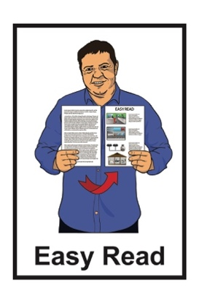






Research study on barriers to work for disabled people:
What we should do now

Published: November 2024

Before you start

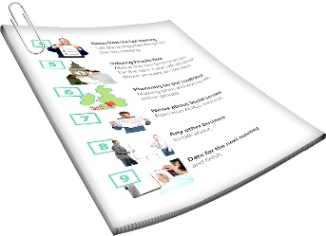
This is a long document.


It can be hard for some people to read a document this long.


Some things you can do to make it easier are:
read it a few pages at a time
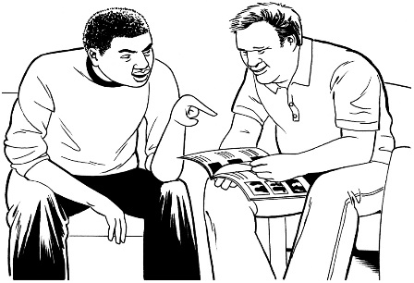
set aside some quiet time to look at it
have someone read it with you to support you to understand it.

What you will find in here

Page number:


What this document is about 4

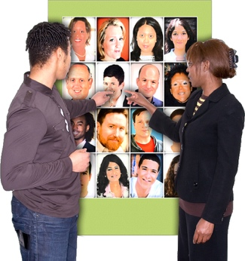
Recommendations for
employers 13

Recommendations for workforce development councils 19


Recommendations for
educators 24

Page number:


Recommendations for
the Government 26


More information 35

What this document is about


This Easy Read document is about some research that was done about the barriers for disabled people to get some types of jobs.


Research is when someone:
looks at what has happened
tries to find ways to do things better.


Barriers are things that make it harder to do the things you need / want to do.

The research was organised by:

Hanga-Aro-Rau / Manufacturing Engineering and Logistics Workforce Development Council

Waihanga Ara Rau / Construction and Infrastructure Workforce Development Council.


When you see we in this document it means:
Hanga-Aro-Rau

and
Waihanga Ara Rau.


A workforce development council supports:
the education system in Aotearoa New Zealand including:
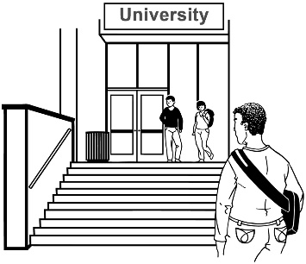
- polytechnics
- wānanga / Māori universities
- apprenticeships

Māori businesses
iwi / tribe development.

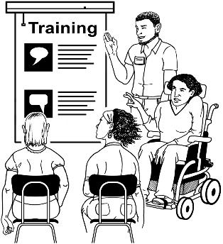
A polytechnic is a place where you can get training in different types of jobs.


Polytechnics are run by the Government.

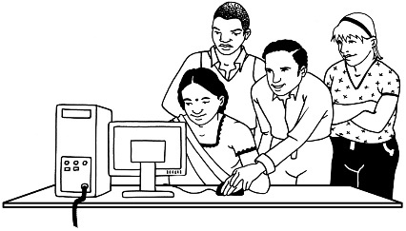
An apprenticeship is a type of job where you learn skills while you work.

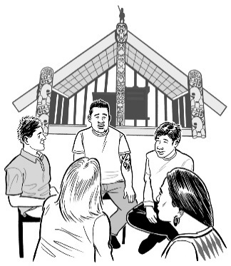
Iwi / tribe development means Māori find ways to do business that supports everyone in their iwi / tribe.


The research is about barriers disabled people face in jobs like:
manufacturing like making things in a factory

engineering like making machines

construction like building
logistics
infrastructure.


Logistics is planning how things get from where they are made to where they are sold.


Infrastructure is the systems of how a business is run like:
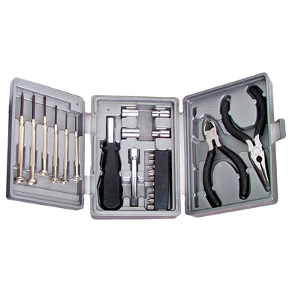
how things are made
hiring people to do the work
getting the tools to do the work.


We call the businesses that do these things industry.

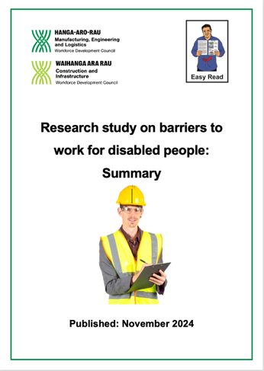
There is an Easy Read summary called:

Research study on barriers to work for disabled people

Summary


You can find this document at:

https://www.waihangaararau.nz/lets-level-up/alternate-formats/


A summary:
is shorter than the full document
tells you the main points.


This Easy Read document has recommendations for things that would make it easier for disabled people to:
get jobs
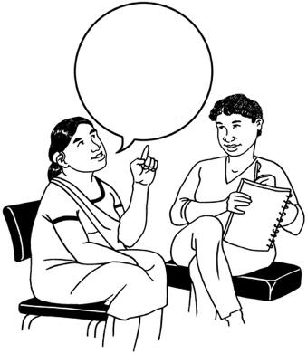
do well in their jobs.

A recommendation says what we think could be done to make things better.


The recommendations in this document are for:
employers
workplace development councils
educators
the Government.


Employers are people who hire other people to do work.

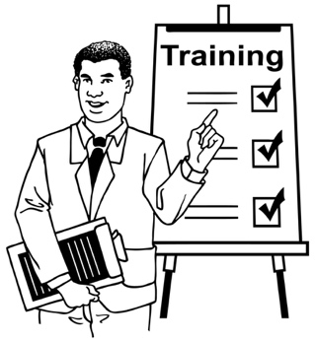
Here educators means the
people / organisations who teach adults.


These recommendations will make industry more:
accessible
inclusive.
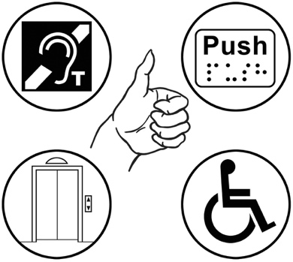

Accessible means everyone is able to do the things they need / want to do.


Inclusive means everyone can take part in the same things.


These recommendations will also support industry to:
do more work
make more money.

Recommendations for employers

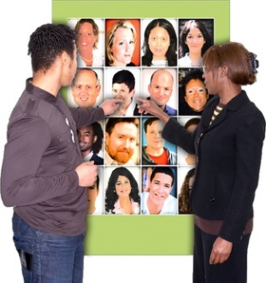
Employers told us they need more workers.


They want their workers to keep working for them for a long time.

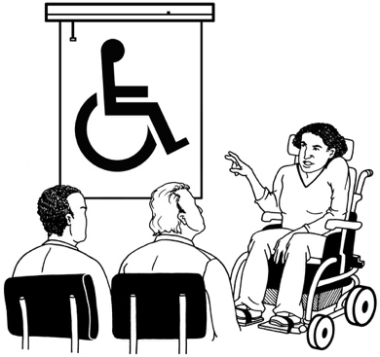
Employers said they need information so they can:
understand disability
support disabled workers.


There is already some information employers can use to make their workplace more inclusive of disabled people.

There is some good information on the Disability Support Services website at:


https://tinyurl.com/2hjw45rj

The website is not in Easy Read.


There are some things employers can do straight away to make their workplaces more accessible like:
having flexible working hours

letting people work from home
using assistive technology.


Flexible working hours means:
not everyone has to do their work at the same time
people can change their hours.

Assistive technology means anything that makes doing things easier for disabled people.



1 example of assistive technology is text to speech software that reads words on a screen out loud.


It is good to kōrero / talk about accessibility in the workplace.

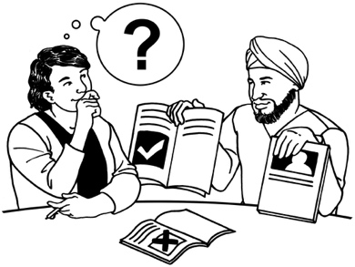
We recommend that employers ask all their workers what support they need to do their job.

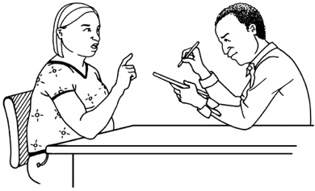
We recommend employers ask new workers about the support they need before they start work.
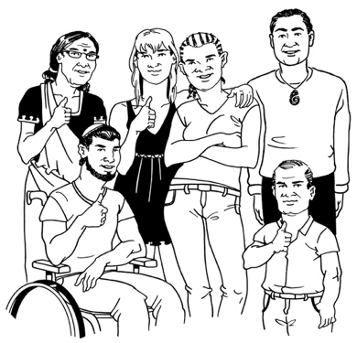

Employers should ask everyone about their support needs not just disabled people.

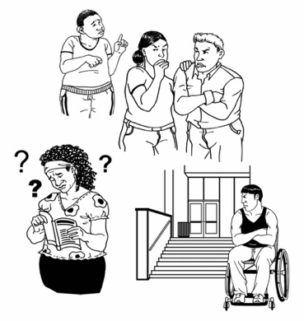
Talking to workers will assist employers to understand:
what their workers need
where there are problems:

- in the workplace
- with how they choose who to hire.
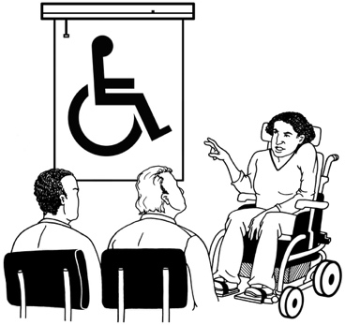
We recommend that employers make sure everyone in their workplace can learn more about disability.


For example everyone in a workplace could learn some New Zealand Sign Language.


Everyone needs to know why understanding about disability is important.

If employers follow these recommendations they will have what they need to make sure their workplaces are inclusive of disabled people.


In an inclusive workplace disabled people will not need to tell anyone about their disability if they do not want to.
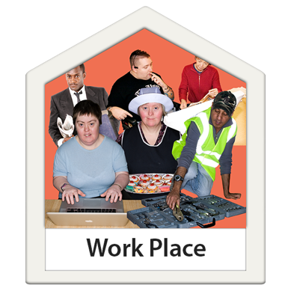

Inclusive workplaces will mean everyone has the support to do their jobs well.

Recommendations for Workforce Development Councils

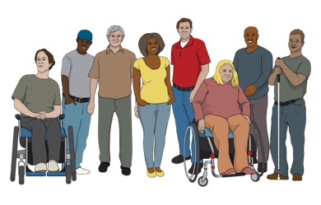
Employers said they want to learn how to:

get disabled people to want to work for them
have training that works well for diabled people.
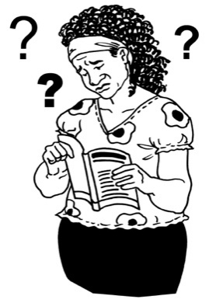

A lot of training for jobs does not work well for disabled people.

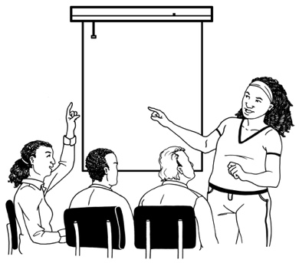
Workforce Development Councils can support employers to have better training for their workers.

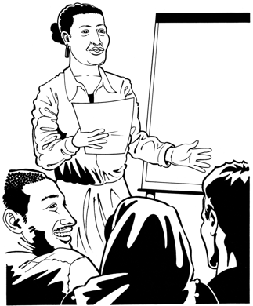
There need to be guidelines for supporting disabled people to:
do training
find jobs.


Guidelines say what the right way to do something is.


A lot of different groups should work together to write the guidelines like:
disablity support organisations
employment agencies
industry associations.
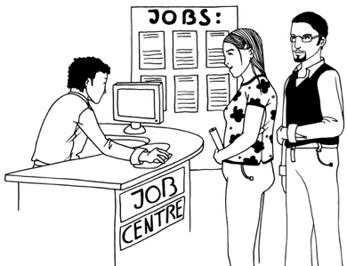

Employment agencies are organisations that assist people to find jobs / workers.

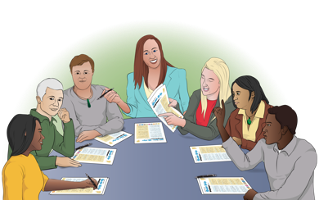
Industry associations are organisations that support businesses.


We recommend that the guidelines are checked often to see how they are working.


We recommend that workforce development councils run awareness campaigns about disability inclusion.

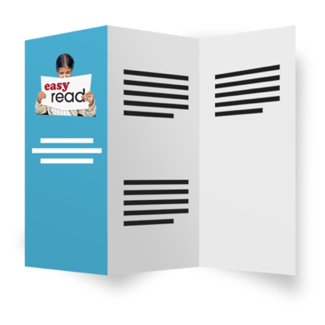
Awareness campaigns are a way of sharing information with a lot of people.


Awareness campaigns could show how different businesses are being inclusive of disabled people.


Other businesses could learn from them.


We recommend that disability support organisations give ongoing support to:
disabled workers
employers.

Here ongoing means something will keep happening.


Ongoing support will make sure disabled people can:
do well in their jobs
feel good about working.

If workforce development councils follow these recommendations:
employers will know how to make their workplaces more inclusive
more disabled people will:
- start jobs
- stay in their jobs.

Recommendations for educators

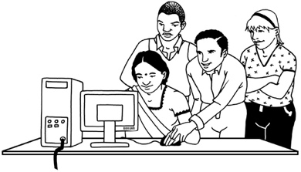
We know that learners do better when they have the right support.

We also know that there are lots of barriers to disabled people:
doing learning courses
getting qualifications.


Qualifications show that you:
have done a learning course
have the skills to do a job.

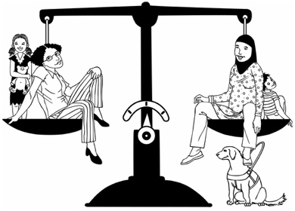
Disabled learners should have the same chance to do well as everyone else.
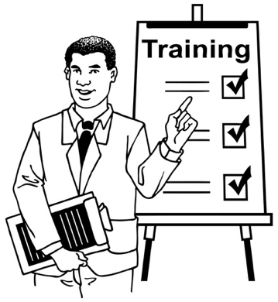
We recommend that educators make sure that their courses work well for disabled people.

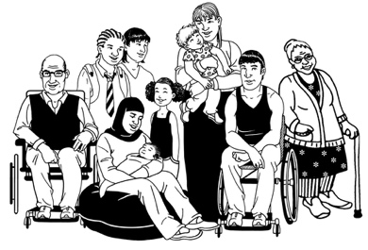
Educators should know how to change the way they teach for different learners.

We recommend that educators run courses for employers to learn more about disability.


If educators follow these recommendations all learners will:
have good support
be able to do well in their learning.

Recommendations for the Government

The Government makes policies that employers have to follow.


Policies are rules made by the government.


Some policies do not work well for disabled workers.


The government needs to think about how to make better policies for disabled workers.


We recommend that the government gets information from:
research
disabled people.

The government should use that research to change its policies to be better for disabled workers.

We recommend that the government give money to employers to support them to have inclusive workplaces.



At the moment employers get money to support individual disabled workers.

Here individual means 1 person at a time.
This makes it harder to think of disabled workers as an ordinary part of the workplace.

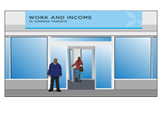
At the moment money to support disabled workers comes from the Ministry of Social Development.

The Ministry of Social Development is the part of Government in charge of things like:
benefits
student loans.

The Ministry of Social Development is also called MSD.


A benefit is money from the Government for people to live on.

If the money came from the Ministry of Business Innovation and Employment it would make having disabled workers more of an everyday thing.

The Ministry of Business Innovation and Employment is the part of Government in charge of things to do with businesses.

It is also called MBIE.

We recommend that the government gives employers incentives to hire more disabled workers.


Incentives are things that make people want to work harder like:
money
prizes.

We recommend that there should also be incentives for employers to learn more about disability.


We also recommend that the government does more research about disabled people:
in education / courses
starting jobs.


The research would show the government:
the best ways to support disabled people
what it should give the most money to.

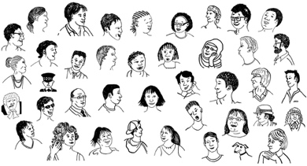
There are a lot of people in
Aotearoa New Zealand who have
fetal alcohol syndrome disorder.

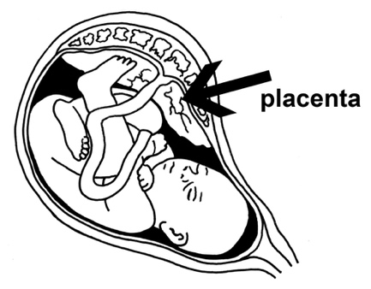
Fetal alcohol syndrome disorder means disabilities that happen to the baby when someone drinks a lot of alcohol while they are pregnant.


Fetal alcohol syndrome disorder is also called FASD.

We need more information about how to support workers with FASD.

We recommend that the government spends money on giving people with FASD support in the workplace.


Transport can be a barrier to disabled people being able to work.

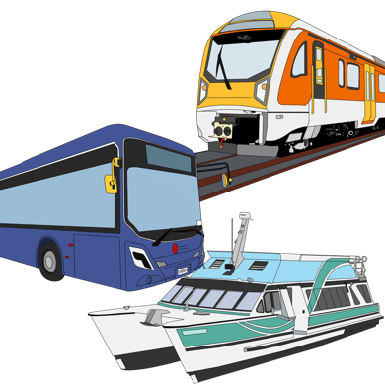
Transport means ways of getting from place to place like:
buses
trains
cars.

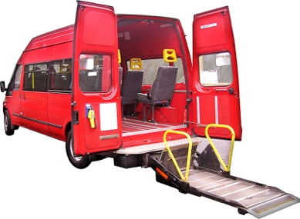
The government needs to think about how to make transport that:
is accessible

does not cost too much money to use.

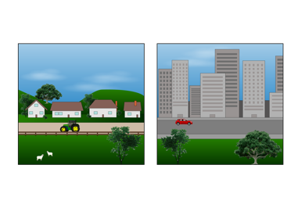
It can be harder to run a business in a small town than it is in a big city.


We recommend that the Government thinks about how it can support businesses in small towns to be inclusive of disabled workers.


If the Government follows these recommendations it will make things better for:
disabled people
businesses
the economy.

The economy is all the ways people:
make money
spend money.

More information

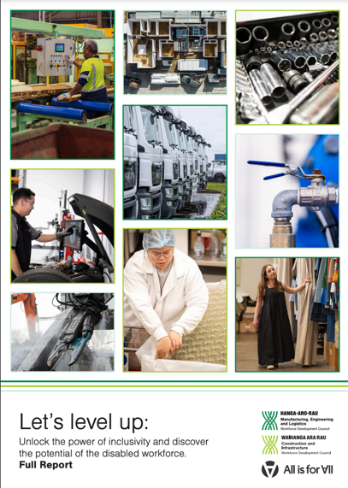
The full report about this research is called:

Let’s level up

You can read it online at:
https://www.waihangaararau.nz/lets-level-up/
The full report is not in Easy Read.


This information has been written by:

- Hanga-Aro-Rau
- Waihanga Ara Rau.


It has been translated into Easy Read by the Make it Easy Kia Māmā Mai service of People First New Zealand Ngā Tāngata Tuatahi.


The ideas in this document are not the ideas of People First New Zealand Ngā Tāngata Tuatahi.

Make it Easy uses images from:


- Changepeople.org


            - Photosymbols.com

- SGC Image Works
- Huriana Kopeke-Te Aho

- T. Wood.

All images used in this Easy Read document are subject to copyright rules and cannot be used without permission.

