
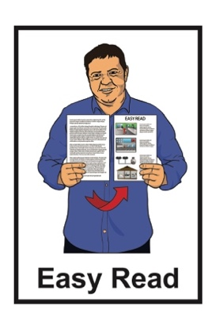




Research study on barriers to work for disabled people:
Summary

Published: November 2024

What you will find in here

Page number:


What this document is about 2

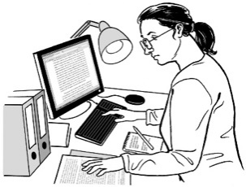
Why the research was done 8

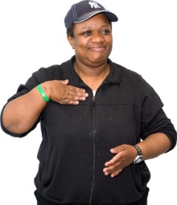
How the research was done 11

What employers said 14
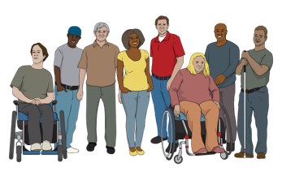

What disabled people said 18


More information 23

What this document is about


This Easy Read document is about some research that was done about the barriers disabled people face when trying to get some kinds of jobs.

Research is when someone:
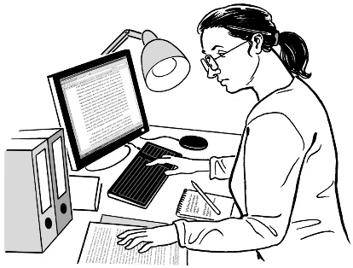
looks at what has happened
tries to find ways to do things better.


Barriers are things that make it harder to do the things you need / want to do.

The research was organised by:

Hanga-Aro-Rau / Manufacturing Engineering and Logistics Workforce Development Council

Waihanga Ara Rau / Construction and Infrastructure Workforce Development Council.

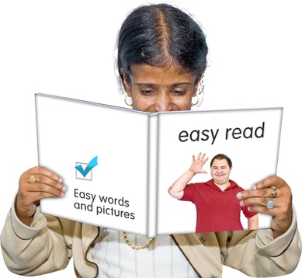
When you see we in this document it means:
Hanga-Aro-Rau

and
Waihanga Ara rau.


A workforce development council supports:
the education system in Aotearoa New Zealand including:
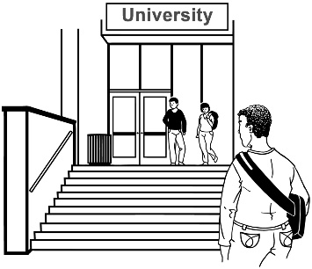
- polytechnics
- wānanga / Māori universities
- apprenticeships

Māori businesses
iwi / tribe development.

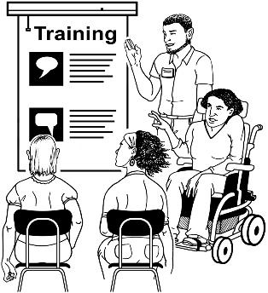
A polytechnic is a place where you can get training in different types of jobs.

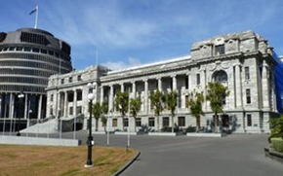
Polytechnics are run by the Government.

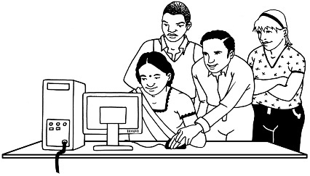
An apprenticeship is a type of job where you learn skills while you work.

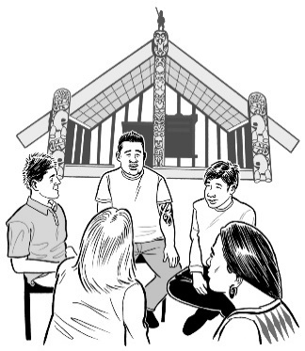
Iwi / tribe development means Māori find ways to do business that supports everyone in their iwi / tribe.


The research is about barriers disabled people face in jobs like:
manufacturing like making things in a factory
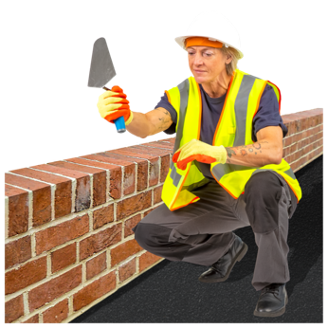
engineering like making machines
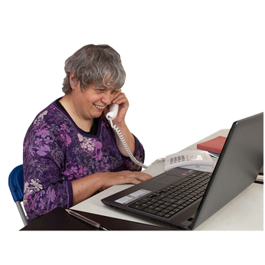
construction like building
logistics
infrastructure.

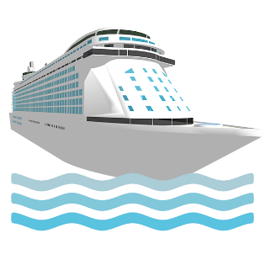
Logistics is planning how things get:
from where they are made
to where they are sold.


Infrastructure is the systems of how a business is run like:
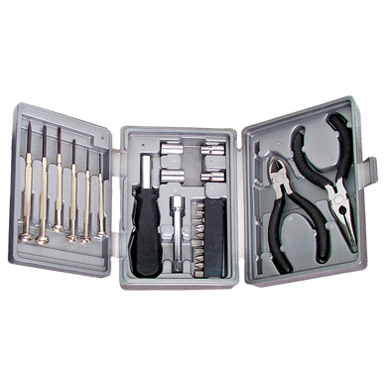
how things are made
hiring people to do the work
getting the tools to do the work.


We call the businesses that do these things industry.

This Easy Read document is a summary of what the research found out.


A summary:
is shorter than the full document
tells you the main points.

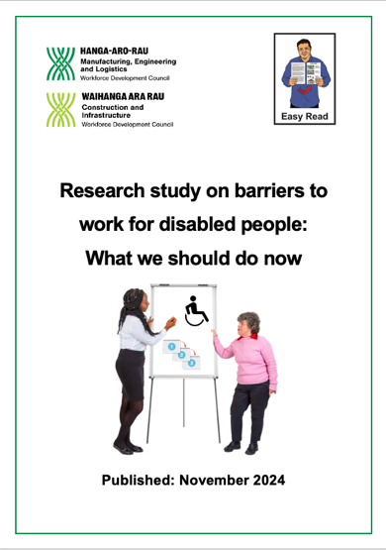
There is another Easy Read document about what the research tells us we should do next called:
Research study on barriers to work for disabled people:
What we should do now.

You can find this document at:
https://www.waihangaararau.nz/lets-level-up/alternate-formats/

Why the research was done

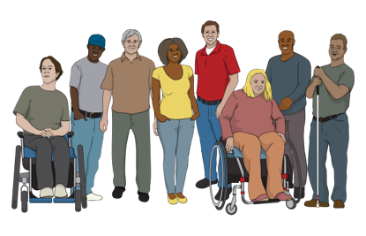
Around half of working age disabled people in Aotearoa New Zealand do not have a job.

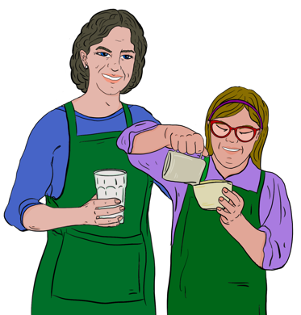
Working age means old enough to get a job.

In Aotearoa New Zealand this is people who are at least 15 years old and older.

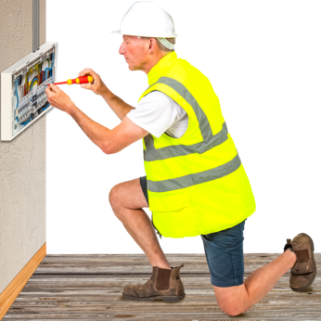
At the same time there are not enough workers in:
manufacturing
engineering.

There are also not enough workers in:
construction
logistics
infrastructure.
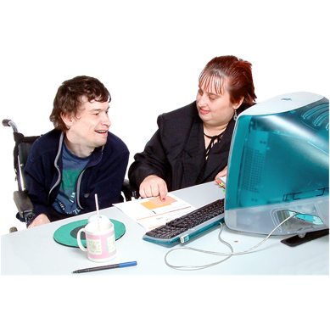

With the right support more disabled people could have jobs.


Disabled people can be really good workers.

Having more disabled workers would be good for industry too.


We know a lot of things have to change to make jobs better for disabled people.
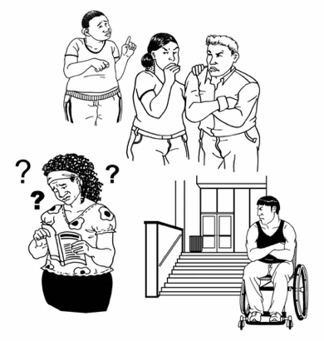

We wanted to know what barriers stop disabled people from getting jobs.

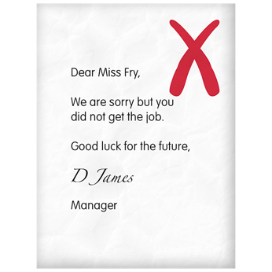
We also wanted to understand why employers do not hire more disabled people to do jobs.


Employers are people who hire other people to do work.

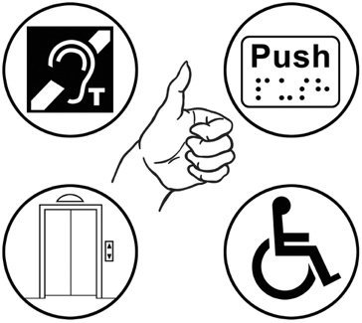
We wanted to find out what needs to change so more disabled people can have jobs.

How the research was done


The research was done by a team of people from:
All is for All


and
The Donald Beasley Institute.


All is for All works with businesses to change how they think about disabled people.

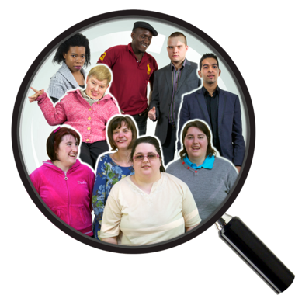
The Donald Beasley Institute does research with disabled people about their lives.

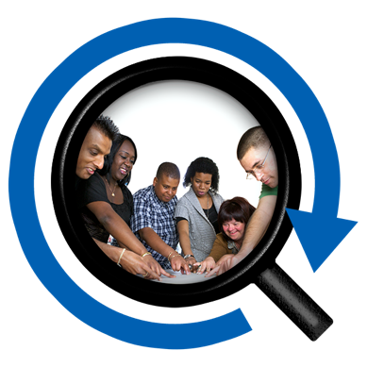
The research team was led by disabled people.

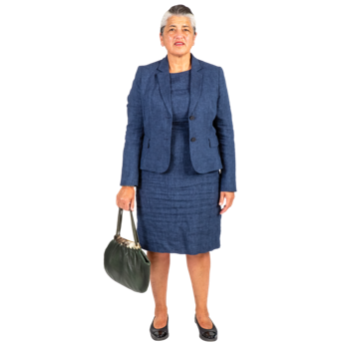
The research team got information from:
employers
disabled people.

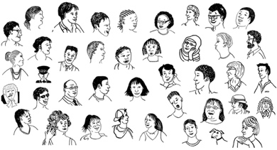
Almost 3 hundred employers were part of the research.

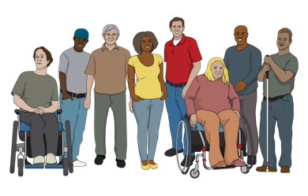
34 disabled people were part of the research.


Some of the employers were also disabled.

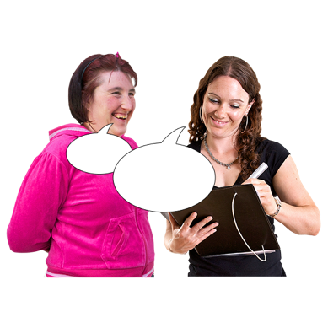
The research team got information from:
surveys
interviews
focus groups.
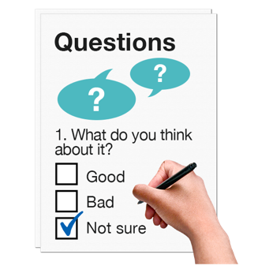

Surveys are when you ask lots of people what they think about something.

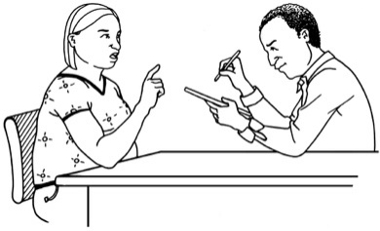
Interviews are when you meet face to face to talk about something.


Focus groups are when a small group of people gets together to talk about something.

What employers said

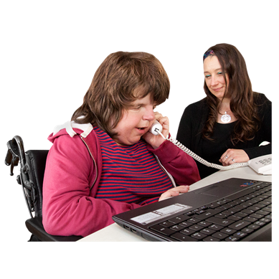
Almost half the employers said they had worked with disabled people.

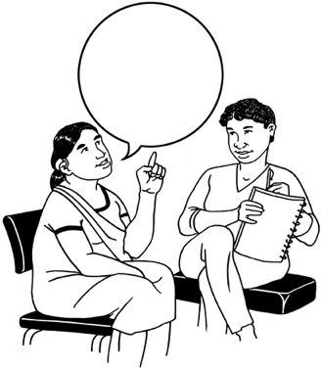


Around half the employers said they had never:
talked about disability in their workplace
thought about hiring disabled people to work for them.
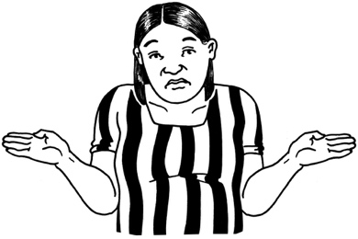

A lot of employers do not know enough about disability.

This is a barrier to them hiring disabled people.

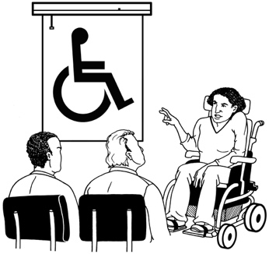
Almost half of employers said they wanted to learn more about disability.


More than half of employers said they were worried about safety in the workplace.

They did not know how to make their workplace safe for disabled people.

They also did not know if having disabled people in their workplace would be safe for other workers.

Worries about safety were a big barrier to hiring disabled people.


Disabled people said worries about safety often turned out not to be a big problem in real life.
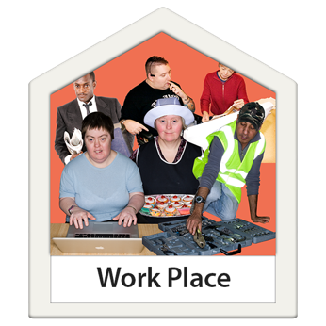
Some employers did not think that there were many jobs in their industry that disabled people could do.

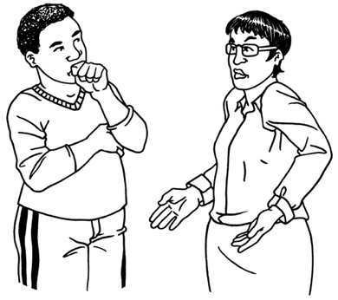
This shows that some employers do not understand what disabled people can do.

The researchers said employers might worry less if they understood more about disability.

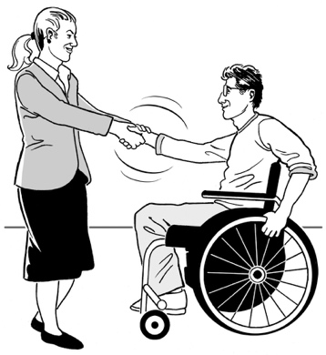
Some employers were working hard to have better inclusion for disabled people

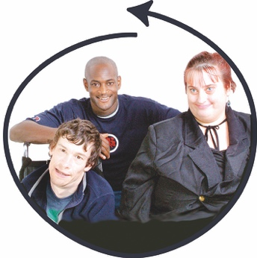
Inclusion means everyone can take part in the same things.

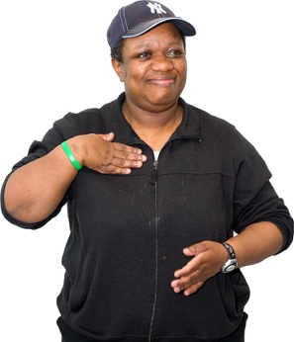
Often it is only 1 person in a workplace pushing for inclusion.

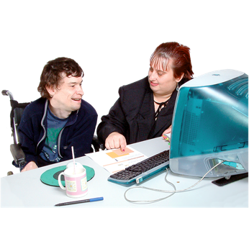
Some employers thought hiring disabled workers was just something to make disabled people feel good.

These employers did not see having disabled workers as an expected part of running a workplace.

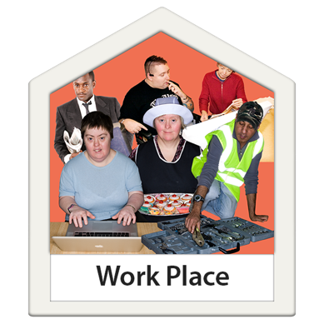
Here expected means something is:
everyday
just the way things are.

We should support employers to change the way they think about disabled workers.

What disabled people said
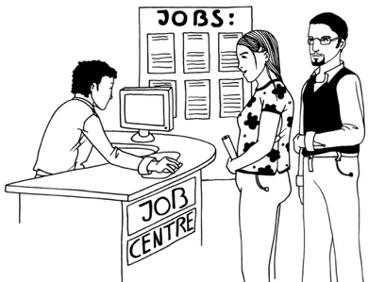

Disabled people said they often needed support to get jobs.
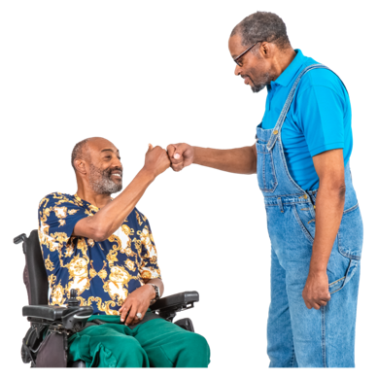

They said they often found jobs through people they already knew.

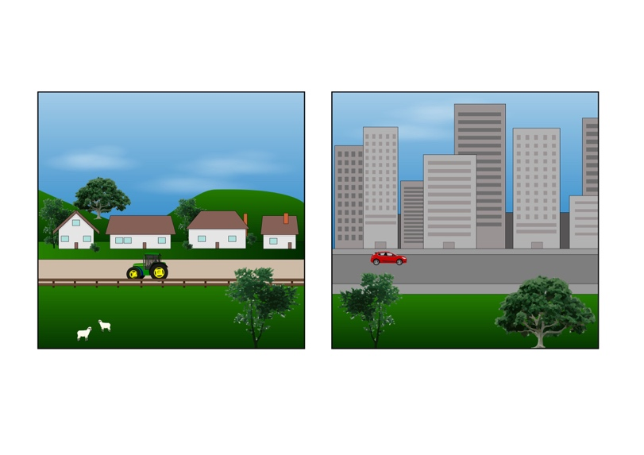
It is easier for disabled people to get jobs when they live in a small town where everybody knows them.

Some disabled people said they could not get jobs even when they had all the right:
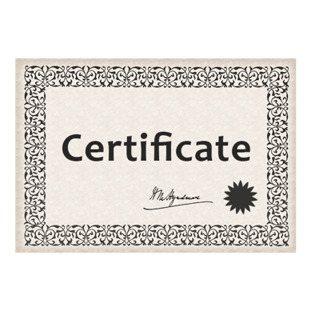
experience
qualifications.

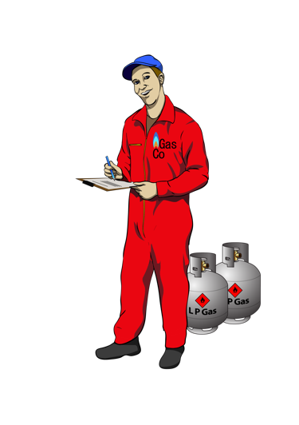
Here experience means someone has:
worked in a job before
got skills from working in a job.

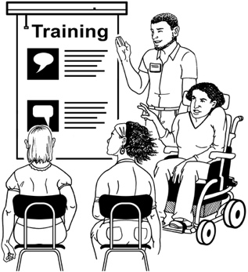
Qualifications show that you:
have done a learning course
have the skills to do a job.

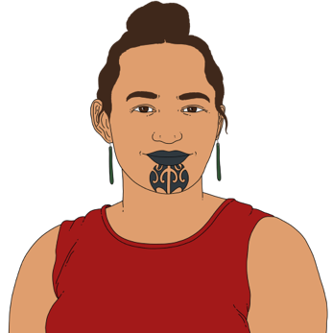
Getting a job was even harder for some groups of disabled people like:
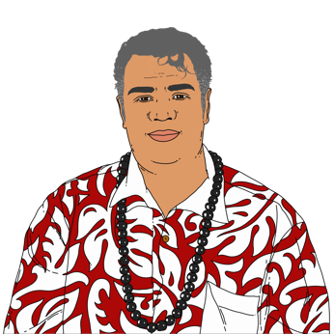
Māori
women
Pacific people.

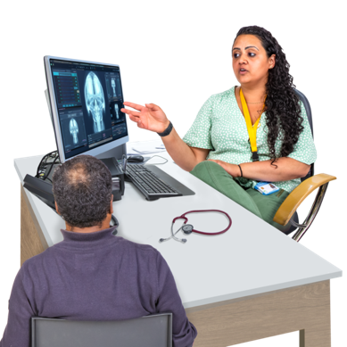
Some disabled people said it was important to have a diagnosis.

Diagnosis means an expert like a doctor has said what the name of your disability / medical condition is.
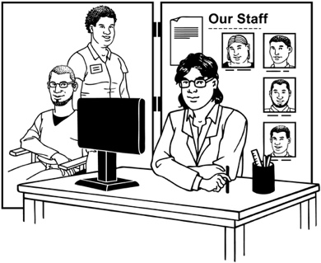

Having a diagnosis makes it easier to ask for support.
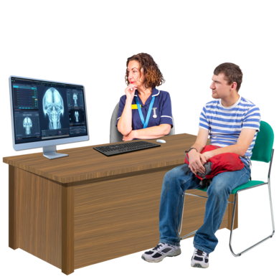

It needs to be easier for people to get a diagnosis.
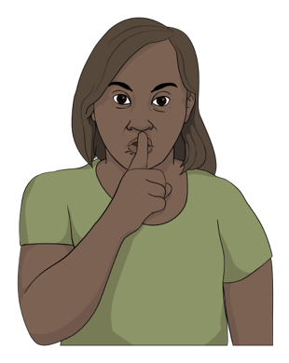
A lot of disabled people do not want to tell their employer about their disability.

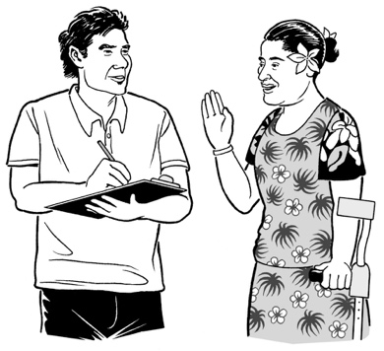
Some employers said they wanted to know more about what disabilities their workers had.

If disabled workers talk about their disability employers might be able to support them better.

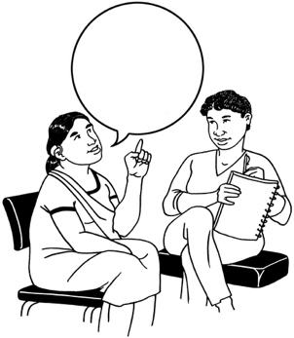

Disabled people need to:
feel safe to talk to employers about their disability
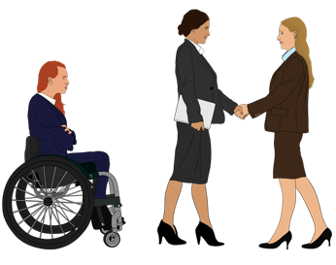
know they will not be treated badly if they say they are disabled.

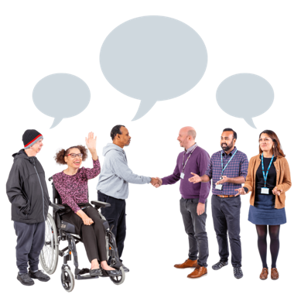
Everyone needs to work together to make workplaces more inclusive of disabled people.

More information

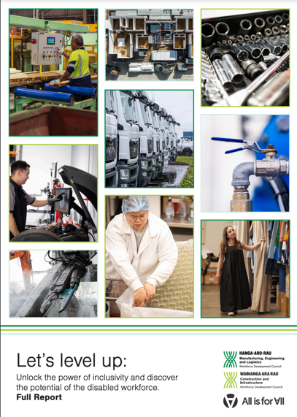
The full report about this research is called:

Let’s level up

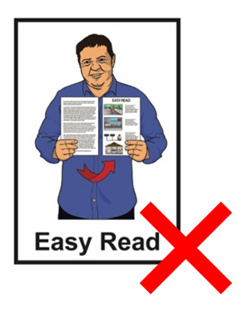
You can read this report at:
https://www.waihangaararau.nz/lets-level-up/

The full report is not in Easy Read.


This information has been written by:

- Hanga-Aro-Rau
- Waihanga Ara Rau.

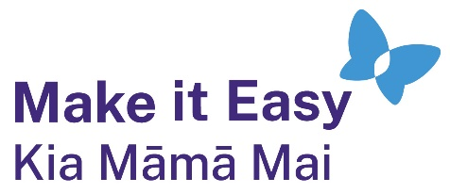
It has been translated into Easy Read by the Make it Easy Kia Māmā Mai service of People First New Zealand Ngā Tāngata Tuatahi.


The ideas in this document are not the ideas of People First New Zealand Ngā Tāngata Tuatahi.

Make it Easy uses images from:


- Changepeople.org


            - Photosymbols.com

- SGC Image Works
- Huriana Kopeke-Te Aho
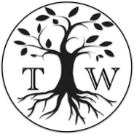
- T.Wood.

All images used in this Easy Read document are subject to copyright rules and cannot be used without permission.

