24 April 2025

Philip Aldridge Ref: PS0708

Chief Executive

Waihanga Ara Rau

Philip.aldridge@waihangaararau.nz

Dear Philip

# Changes to the work-based learning system

I am writing to share with you the government’s decision on the model for delivering work-based learning which will be implemented in January 2026. This follows my announcement in December on the future of vocational education, and the targeted consultation I held with industry in February.

Cabinet has approved my recommendation to introduce an industry led independent work- based learning model. Under this independent model, vocational education and training providers, including private providers, polytechnics, and Wānanga will be able to manage all aspects of an apprenticeship or traineeship in the future.

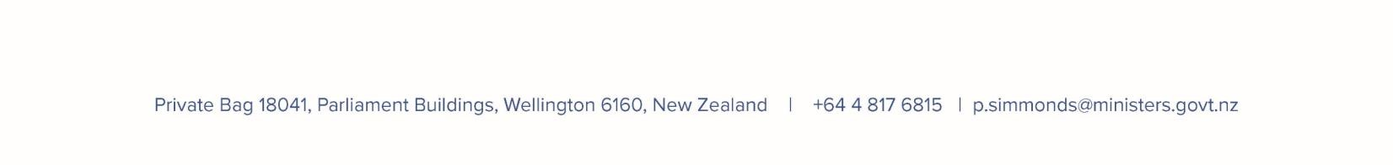Industry stakeholders have told us that they wanted stronger influence and control in vocational training across New Zealand. Our new model will deliver this for both work-based training and the development of qualification and training standards.

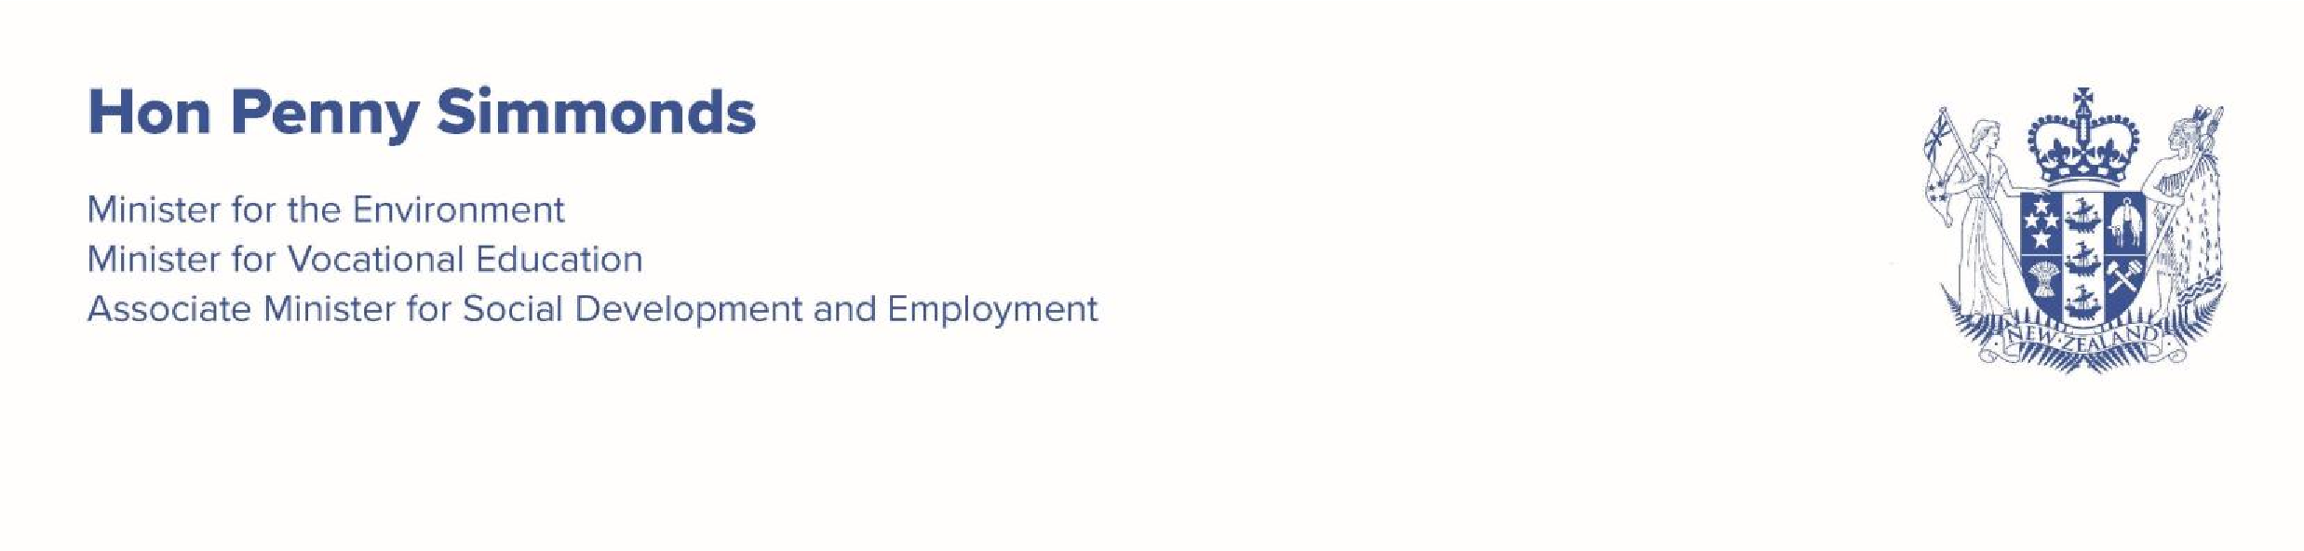

New Industry Skills Boards (ISBs) will ensure the qualifications needed by employers across the country are available to all providers. They will also quality assure the programmes developed by individual providers to ensure they are delivering the skills an industry need. ISBs will be established on 1 January 2026.

Building a network of new work-based learning providers will take time and transition arrangements are required. To support industry to drive this process Cabinet has agreed to a revised transition approach which will see the ISBs, which are industry led organisations, temporarily manage the apprentices and trainees who are currently enrolled with the work- based learning (WBL) business divisions in Te Pūkenga.

The WBL divisions will transition to ISBs on 1 January 2026. They will not be integrated into ISBs but report into the organisations as separate business divisions. This will help facilitate smoother transitions for apprentices and trainees into the new providers as they stand up over the next two years.

I expect that industry will work with the ISBs at pace to determine how to make the most of the opportunity to create industry owned PTEs that will continue the work of the WBL business divisions and develop and deliver new programmes whilst also looking at opportunities for other existing providers

(polytechnics and wānanga) to support work-based learning across New Zealand communities.

*Next Steps*

I appreciate that you and your stakeholders may have questions about the new based learning system, and especially the transition approach. The TEC will be providing information webinars for industry representatives and other relevant groups, outlining the decisions and the next steps in more detail.

Consultation on the number of Industry Skills Boards and their coverage will begin soon and I encourage you to take part in the consultation process. You will receive more information on this from the TEC.

The decisions on which institutes of technology and polytechnics will be established as stand- alone entities in 2026 will be communicated midyear, together with the number and coverage of ISBs.

I acknowledge that these changes might be unsettling for those working in the sector. One thing that doesn’t change is that New Zealand needs a strong vocational education and training system to ensure our people, industries and communities can thrive. I thank you for your continuing support for and participation in this sector.

Yours sincerely

# Hon Penny Simmonds Minister for Vocational Education